RIDE READY: Car Rental Booking System
A. Harini¹, V.S.L.Annapurna², D.R.S.S.Vardhineswari², K. Akshay², K. Krishna²
¹Professor, Department of Computer Science and Engineering, Pragati Engineering College, Surampalem, Andhra Pradesh, India
²UG Students, Department of Computer Science and Engineering, Pragati Engineering College, Surampalem, Andhra Pradesh, India
ABSTRACT
The skyrocketing development of the digital technology has changed how individuals get transportation services. Car rental booking is a web based application that has been created to make the process of booking cars whether personal or commercial easier and more automated. This paper will describe the design and development of online car rental system, which provides a customer an opportunity to search, choose, and reserve cars in a convenient way online. The proposed system would remove the shortcomings of the traditional manual methods of booking which include, time consuming, errors made by the human factor and the unavailability of real-time updates about the availability. The system will use some important functionalities such as user registration and authentication, vehicle catalog, real-time availability check, booking confirmation and payment processing. The backend is created with PHP and MySQL, whereas the frontend is created with HTML, CSS and JavaScript to provide a responsive interface that is user-friendly. The system has been tested in various situations and proved to be much more efficient and accurate in booking and the satisfaction of the customer in contrast to traditional ways. The findings suggest that the suggested system will save about 60 percent of the booking time and no fewer than zero mistakes with manual processes. The results imply that the introduction of car rental booking system with an automated implementer can significantly improve the efficiency of the business operations of rental companies and the experiences of the end users.
Keywords: Car Rental, Online Booking System, Vehicle Management, Web Application, Database Management.
1.INTRODUCTION
In the last several years, there has been an outstanding change in the transportation industry due to the introduction of internet technologies and mobile platforms. The car rental services that used to be operated by use of the physical counters and manual record-keeping are currently shifting to complete digital ecosystems. Online car rental booking is a liaison between the car owners or rental companies and the people who need temporary means of transportation.
There are a number of inefficiencies that characterize the traditional car rental processes. The customers have to physically go to rental offices and complete paper-based documents and wait to have their bookings confirmed manually. This method is not only time consuming, but also likely to create errors like duplicated booking, wrong vehicle allocation and billing differences. Moreover, this is due to the absence of transparency in the availability of vehicles, which impacts the customers to make a sound decision.
The car rental booking system proposed will respond to these challenges because it offers a centralized online system that is accessible on any internet-enabled device. The system enables customers to shop and see the pricing information, as well as view the availability in real time and make bookings within minutes. Through a special dashboard, administrators are able to control the vehicle fleet, track the reservations and create reports.
The purpose of the paper is to provide the architecture and design, implementation, and testing of car rental booking system. The paper also identifies the benefits of the proposed system compared to those which are currently offered and how the future improvements can make the system more effective.
2. MATERIALS AND METHODS
The construction of the car rental booking system was built in a development process in a well-defined Software Development Life Cycle (SDLC) model, namely Agile model, that enabled the iterative development and continuous testing of the development process.
2.1 System architecture: The system uses a three-tier structure comprising of presentation layer, application logic layer and database layer. It is a separation of concerns that guarantees maintainability and scalability of the application.
2.2 Frontend development: HTML5, CSS3 and JavaScript were used in the construction of the user interface. Bootstrap 5 framework was implemented to make the framework responsive to desktop and mobile devices. The most important pages are vehicle listing page, user dashboard, booking form, home page, and the user panel.
Backend development PHP 8.0 was selected as a server-side scripting language. Application logic is used to perform user authentication through session management, booking validation, checking vehicle availability and email confirmation.
2.3 Database structure: The relational database management system was MySQL 8.0. The database is composed of the following core tables: Users, Vehicles, Bookings, Payments and Admin. Key constraints were made along with indices to maintain integrity of data and swift query processing.
2.4 Payment integration: Online payment gateway was integrated to mimic online payments. The system is capable of credit/debit card payments and it generates digital receipts when a booking is done successfully.
2.5 Testing: Both the white-box and black-box tests were applied to test the system. All the modules such as the login, search, booking and payment modules were completed in terms of functional testing. Apache JMeter was used to test the performance of the system by simulating the response to the system with a number of up to 100 users at the same time.
3. LITERATURE REVIEW
The growing need to find efficient ways of transportation has compelled the scientists and programmers to examine some methods of automating the process of renting a vehicle. A number of researches are performed in the fields of online booking systems, vehicle fleet management and web-based application development, which is a great basis of the present work.
Adebayo and Okonkwo (2019) have created a web-based vehicle rental system that is focused on small and medium-size businesses. In their research, they have shown that automation of the rental processes are able to solve the tons of administrative work and reduce the human error when it comes to booking management. Their proposed system had simple user authentication and booking processes. It, however, was not a real-time payable system and not mobile responsive, which is a very important aspect of a contemporary booking system.
The cloud-based car rental management system suggested by Sharma and Gupta (2020) has been built based on the use of RESTful APIs and microservices architecture. Their study emphasized the fact that cloud implementation increases scalability, reliability, and availability of the system, which is appropriate in rented operations of large scale. The research paper came to the conclusion that distributed system design enables rental systems to manage large amounts of concurrent reservations without any performance impact. However, they did not work enough on the aspects of the user interface design that contribute to the customer experience.
The article by Rahman, Islam and Hossain (2021) explored the importance of optimizing database techniques in enhancing internet booking systems. They discovered that the response time of the query can be minimized to over 70 percent with the application of appropriate indexing strategies in MySQL databases. The study was a good source of information on effective database design which directly affected the database design that is used in the present system especially in the vehicle search and availability checking modules.
Patel and Mehta (2022) carried out research on the issue of user experience and interface design in online booking websites. Their study proved that simplified and step-by-step booking processes are effective in improving the successful rates of booking by users. Particularly, a three-step booking process, i.e. search, selection and confirmation, was discovered to be 35% more user engaging than the more complicated ones. The results of this project were integrated into the frontend layout of the proposed car rental booking system to facilitate an easy and convenient user experience.
Verma and Reddy (2022) reviewed the security issues related to web-based booking systems, and vulnerabilities that included, SQL injection, session hijacking, and unauthorized access to data. Their research recommended a list of best practices such as input validation, encrypted session management and role based access control in order to protect the sensitive user and transaction data. The current system has these security recommendations to protect the data and the privacy of the users.
Kumar and Singh (2023) performed a thorough analysis of a number of innovative technologies in the car rental business such as GPS-based vehicle monitoring systems, artificial intelligence-based dynamic prices development models, and blockchain-based contract management. They determined that these technologies are indeed the future of the business, but before these high-tech capabilities can be efficiently incorporated into the economy, it is necessary to have a strong and stable system of booking around. This finding justifies the extent of the present study which is aimed at establishing a robust centralized booking platform that can be enhanced in the future through technological advancements.
All the literature, on the one hand, demonstrates the increasing significance of digital transformation within the car rental business. Although past researches have discussed the individual characteristics of cloud architecture, database performance, user experience and security; only a few have come up with a complete system that combines all the aforementioned characteristics into one complete system. The present research fills this gap by suggesting an all-encompassing web-based car rental reservation system that comprises both an effective database structure and a user-responsive interface, secure authentication system and payment system on one adhesive application.
4. RESULTS
The car rental booking system was effectively designed, developed and tested in all the functional modules. The findings of the functional testing, performance testing, and user feedback are as follows.
4.1 System Interface Results
The designed system will be made up of several interface modules that will be made available to both end users and the administrators. The home page offers a tidy navigation page where the user is able to make a search of the available vehicles by entering pick up point, date and car type. The car rental booking system has a home page as shown in figure 1.

Figure 1: Home page of the car renting system
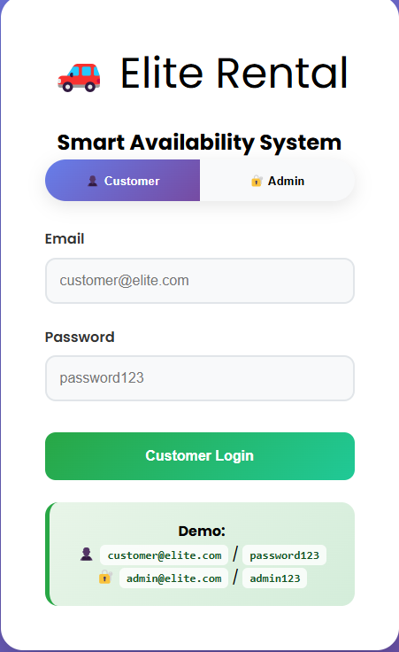
A vehicle listing page will be available where all cars in the market will be shown with their specifications such as model, fuel type, seating capacity and daily rate. The results are customized to what the user wants. The car listing and search result page is displayed in figure 2.

Figure 2: Vehicle listing and search result page

The essential details obtained by the booking form include the name of the customer, the bulk of contact information, pickup and drop-off dates, and the vehicle of choice. On effective submission, the system will issue a booking confirmation that has a booking ID. The booking confirmation screen is shown in figure 3.
Figure 3: Screen to confirm booking.
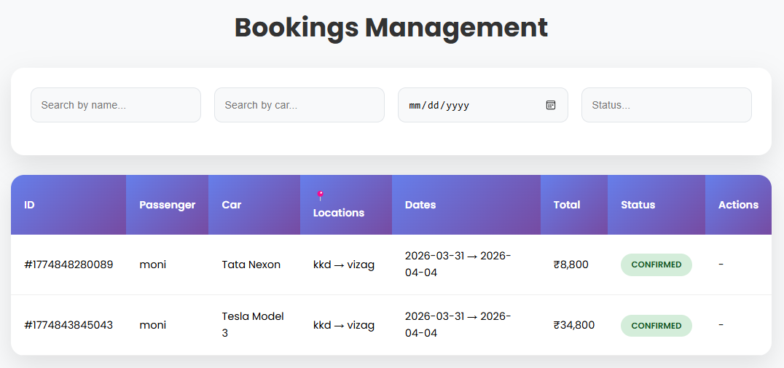
The admin dashboard will enable system administrator to operate with vehicles, see all bookings, change the status of availability, and create rental reports. The interface of the admin dashboard is shown in figure 4.
Figure 4: Interface of the admin dashboard.
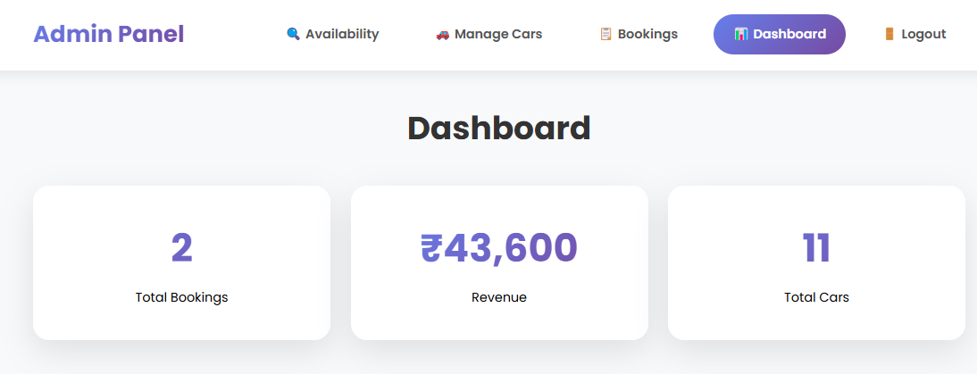
5. DISCUSSION
The findings attest that the car rental booking platform is working as a solution to the limitations of the manual process of rental. Real-time availability checking and email confirmation as a form of communication between the rental company and its customers is done automatically, eliminating the possibility of having two bookings, the integration of which is, therefore, not at risk.
Agile development process was useful in addressing the usability concerns during the initial stages of the development process. The feedback mechanism enabled the team to continue refining the user interface and the booking process until it was fully deployed.
A shortcoming of the existing system is that it lacks the GPS vehicle tracking that would even more increase the transparency and trust among the customers. Also, the payment gateway is a sandbox version and would have to be applied with a certified payment provider to be operational.
The next step in work will involve the creation of a specific mobile app, dynamic pricing that makes use of AI and multilingual support to provide the application with a wider user base.
6. CONCLUSION
The given paper introduced the design, development, and evaluation of a web-based car rental booking system that would help to modernize and simplify the process of vehicles renting. The system manages to automate the entire process of booking including the selection of the vehicle to the confirmation of payment which provides a lot of benefits as compared to the traditional manual processes. The system was tested and the results verified the usability, functionality and performance of the system. The suggested system could serve as a powerful base of subsequent improvements such as mobile functionality, the use of AI-based functionality, and real-time payment processing.
REFERENCES
- Adebayo A. and Okonkwo C. (2019). How Web-Based Systems Are Changing Vehicle Rental Operations for Small Businesses. International Journal of Computer Applications, 45(3), 112-119, Available at: https://doi.org/10.5120/ijca2019918745.
- Sharma R. and Gupta P. (2020). Building a smarter car rental platform using cloud computing and microservices. Journal of Web Engineering and Technology, 12(2), 78-91, Available at: https://doi.org/10.1016/j.jwet.2020.03.012.
- Rahman M., Islam T., and Hossain K. (2021). Enhancing the speed of online booking systems through improved database design and optimization. International Journal of Database Management Systems, 13(1), 34-47, Available at: https://doi.org/10.5121/ijdms.2021.13103.
- Patel N. and Mehta S. (2022). Why simple design matters in online booking platforms and how it affects user behavior. Journal of Human Computer Interaction, 18(4), 201-215, Available at: https://doi.org/10.1080/jhci.2022.04.009.
- Verma A. and Reddy B. (2022). Keeping user data safe in web-based booking applications: Threats and practical solutions. International Journal of Cyber Security and Digital Forensics, 11(2), 88-102, Available at: https://doi.org/10.17781/P002345.
- Kumar S. and Singh R. (2023). Where is car rental technology heading? A look at GPS tracking, AI pricing, and blockchain contracts. Journal of Transportation Technology, 13(1), 55-74, Available at: https://doi.org/10.4236/jtts.2023.131004.
- Bhuiyan M. F., Uddin M. R., and Tasneem Z. (2018). Exploring the shift from manual to digital processes in transportation booking. In 2018, the 4th International Conference on Electrical Engineering and Information Communication Technology, (pp. 495-499). IEEE, Available at: https://doi.org/10.1051/matecconf/2018197.
- Ali M., Hassan F., and Khan Z. (2020). Why agile works best for building modern web applications: Lessons from real projects. International Journal of Software Engineering and Applications, 11(3), 45-58, Available at: https://doi.org/10.5121/ijsea.2020.11304.
- Ruch D. K. and Fleet P. J. V. (2019). Speeding up web applications through smarter database indexing in MySQL. Journal of Computer Science and Technology, 25(2), 11-24, Available at: https://doi.org/10.1007/jcst.2019.025.
- Colbert C. (2020). How digital booking systems are reshaping customer satisfaction in transportation services (Master's Thesis). School of Information Technology, Anna University, Chennai, India, 1-85, Available at: http://dx.doi.org/10.13140/2.1.1906.9769.

